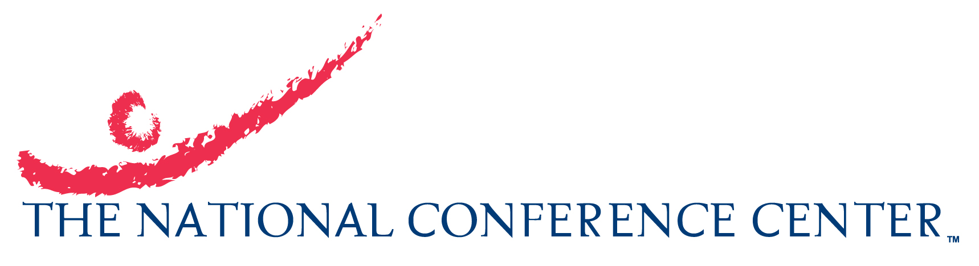

Postharvest Biocontrol Workshop – No Credit Card Form/reservation request
Use this form only if you intend to pay by cash or traveler cheques.
KINDLY NOTE: In such case you will be required to pay, upon check-in, for your
full stay @ $154.00 per night, an additional $25.00 per night to cover extra incidentals you may incur plus the registration fee appropriate to your attendee type (see USDA Second circular). The unused balance of these incidental funds will be returned to you when you check-out.

Name:
Street/Apartment Address:
City & State: |  |  |  |  |  | Postal code:
Country:
Phone: |  |  |  |  |  | Fax:
Email Address:
*Email address is required. You will receive a reservation confirmation via email.
Arrival Date: |  |  |  | Departure Date:
Please indicate kind of occupancy.
(If Double, please provide 2nd guest’s name.)
Special Requests, e.g. (wheelchair access, late check-in):
Special Dietary Requests:
Internal use (# 22964)
REMARKS:

Please complete this form and E-mail it to NCC Reservations. A reservation confirmation will be e-mailed to you from NCC Reservations within 5 business days from the date you send in the form.
If you need to make arrangements for transportation from Dulles International Airport, please submit the electronic form available at this link.
For double occupancy, you will need to pay the Registration fee as outlined in the USDA circular for Accompanied Partner. This is for accommodation, use of the facility, meals, etc. (irrespective of the meals being taken or not).
To cancel your reservation, please e-mail NCC Reservations.
NOTE: All lodging price quoted is inclusive of taxes, currently 10%. Tax rates are subject to change without notice.

